Exotics Boarding Brochure

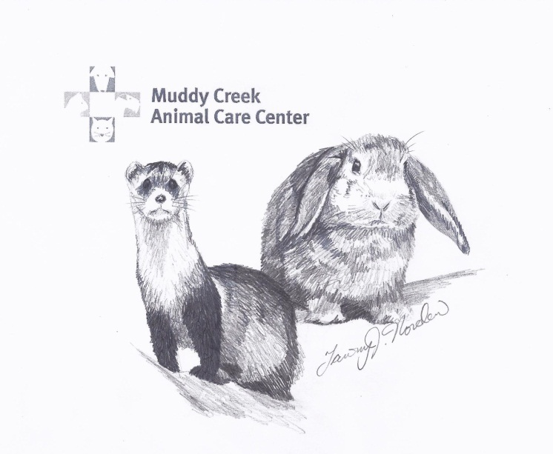

Muddy Creek Animal Care Center
993 Haverhill St.
Rowley, Mass. 01969
978-948-2345

2023 BOARDING PRICES

*Please bring in all of your pet’s essentials and accessories

Ferrets

*Single Ferret: $32 per day
*Each additional ferret in same cage
$16.00 per day

Includes three walks a day
morning, noon, and evening.

Rabbits

*Each rabbit: $19 per day

Added services are available for $8.00 half hour:
Sunbathing
$8.00 per 15 minute session:
Pen Playtime

2022 BOARDING POLICIES

HOURS FOR DROP OFF & PICK UP
Monday 8-11am, 3-6pm
Tuesday 8-11am, 3-6pm
Wednesday 8-11am, 3-6pm
Thursday 8-11am, 3-6pm
Friday 8-11am, 3-6pm
Saturday 8-11am, 1-2pm
Sunday 8-11am, 1-2pm

Phone: 978-948-2345
Please call with any questions or stop by for a tour!

Medication Administration Fees
∗Oral/topical medications once
per day $5.00

∗Oral/topical medications twice or more
per day $8.00

VACCINATION REQUIREMENTS

All ferrets must be current on required vaccines within 5 days of boarding:

Ferrets: Rabies, Distemper
Rabbits: none required

We cannot board
unneutered male rabbits and ferrets.
.
All boarding animals must be flea and tick free. If there is evidence of flea/tick infestation, your exotic pet will be unable to board.

